EXPERRIMENT-7

AIM:

Simulating different types of diode clippers and clampers and obtaining the output wave form of each model from the MULTISIM.

MULTISIM:

SERIES CLIPPERS:

POSITIVE SERIES CLIPPERS

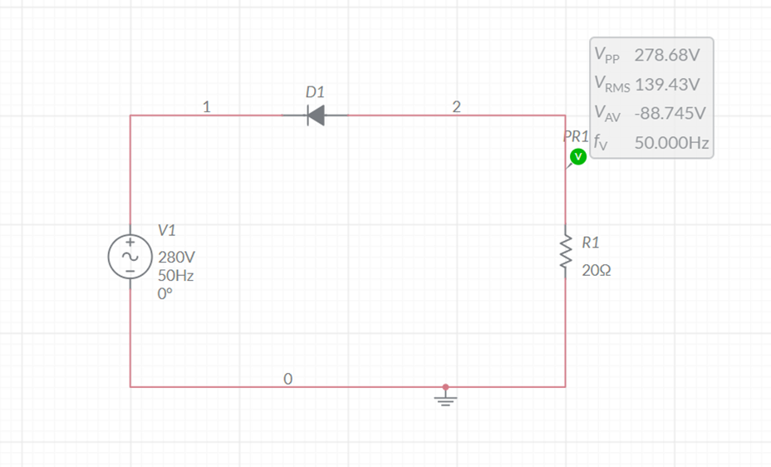

GRAPH:

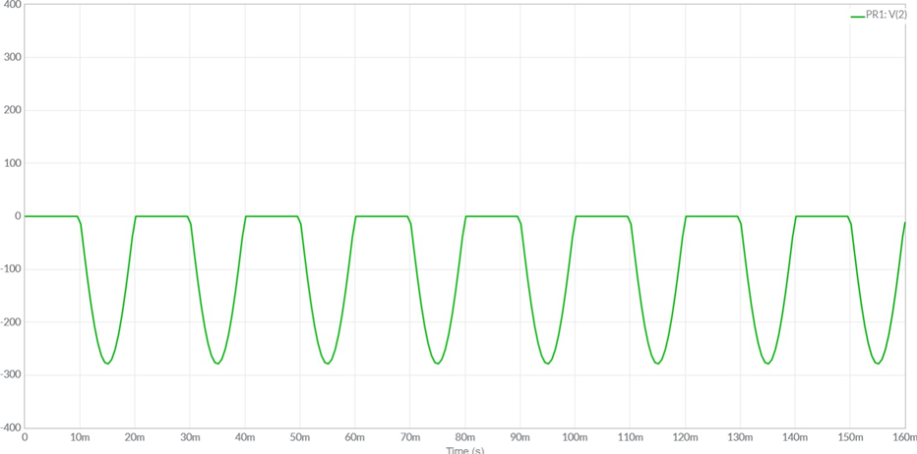

NEGATIVE SERIES CLIPPER

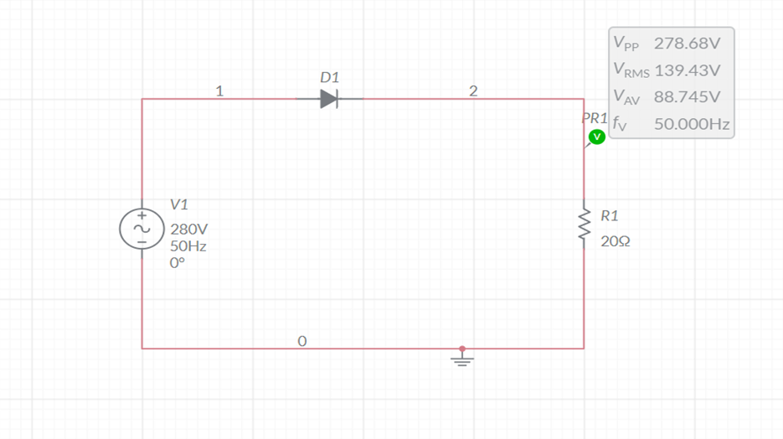

GRAPH:

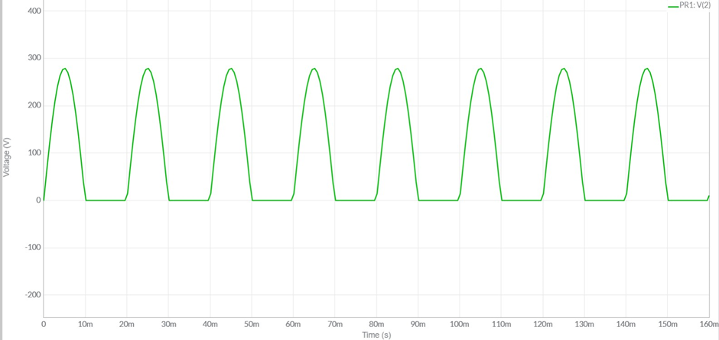

SHUNT CLIPPERS:

POSITIVE SHUNT CLIPPER

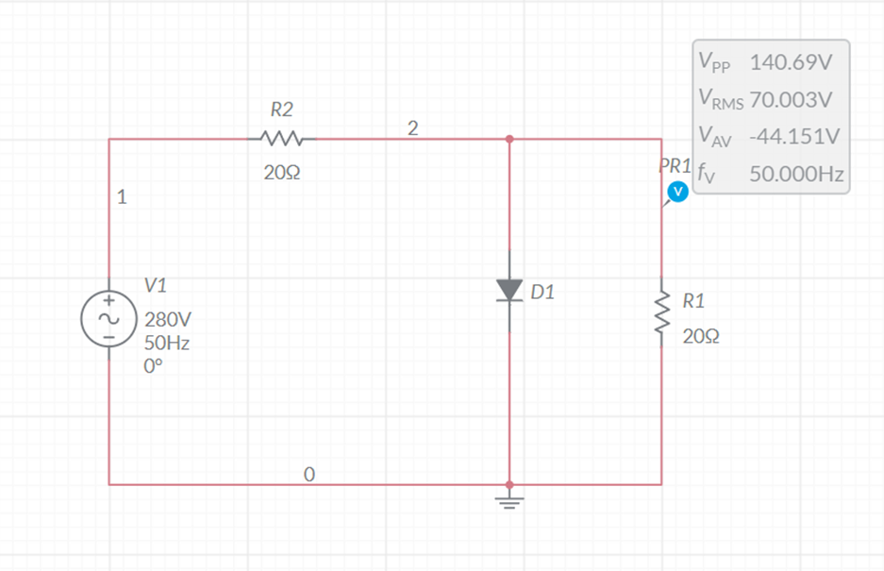

GRAPH:

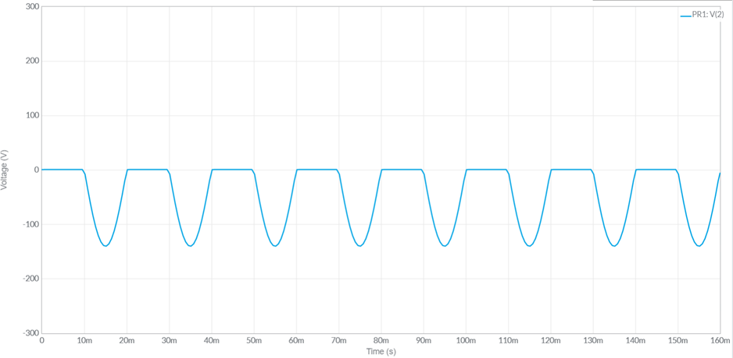

NEGATIVE SHUNT CLIPPER

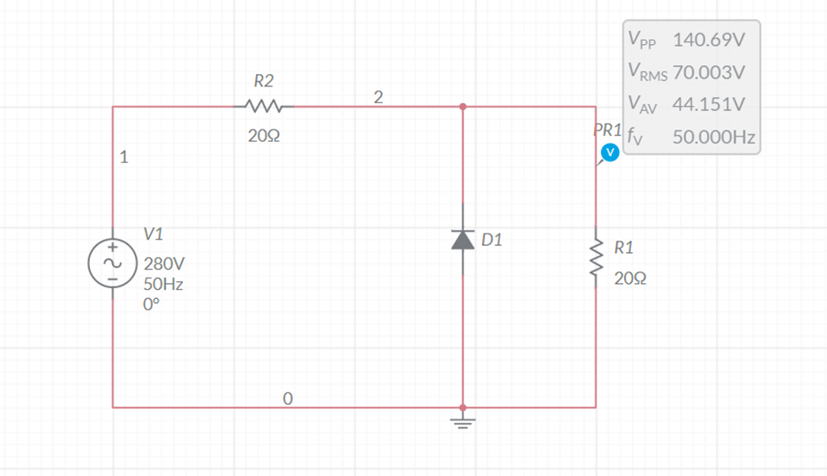

GRAPH:

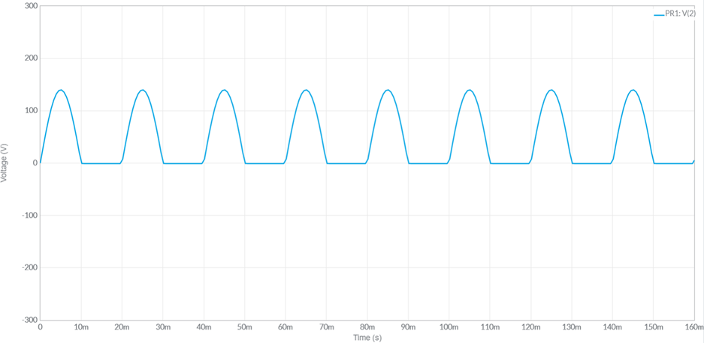

CLAMPERS:

POSITIVE CLAMPER (UNBIASED):

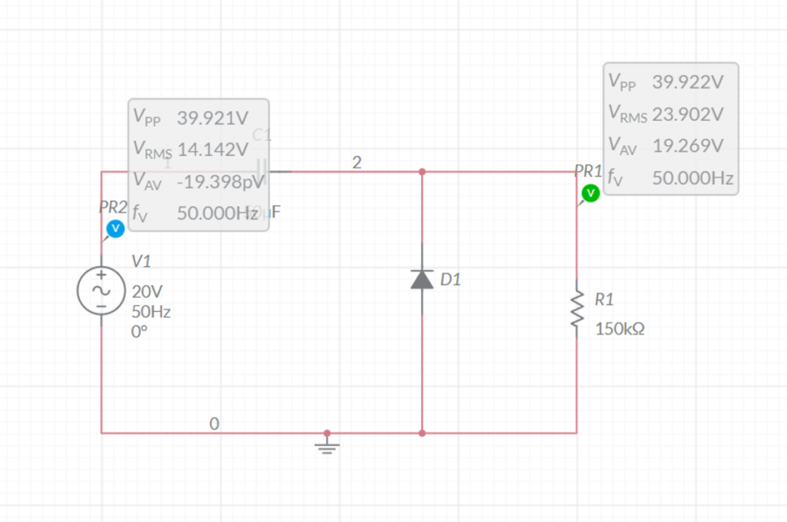

GRAPH:

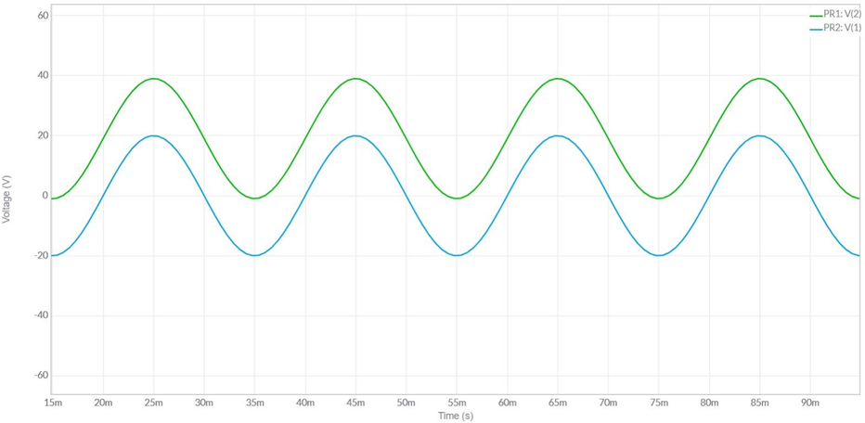

POSITIVE CLAMPER WITH POSITIVE Vr :

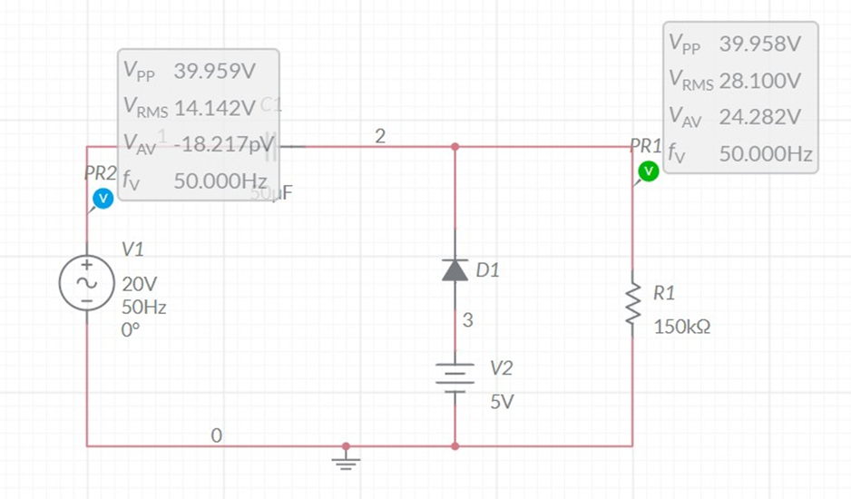

GRAPH:

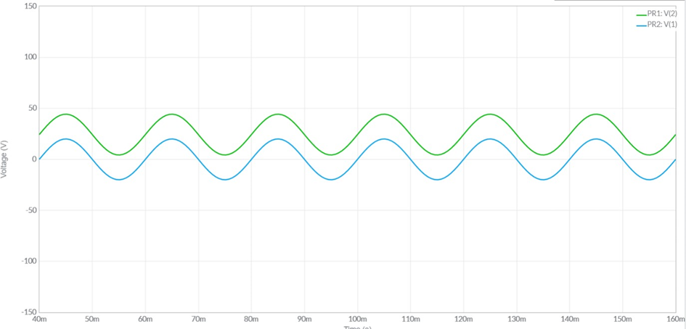

POSITIVE CLAMPER WITH NEGATIVE Vr:

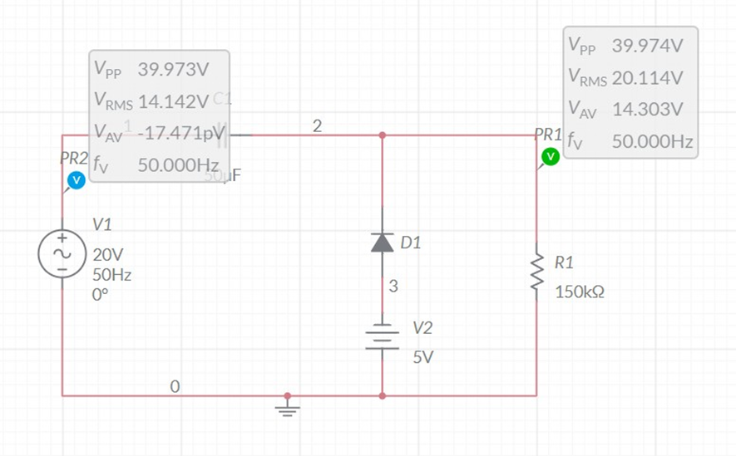

GRAPH:

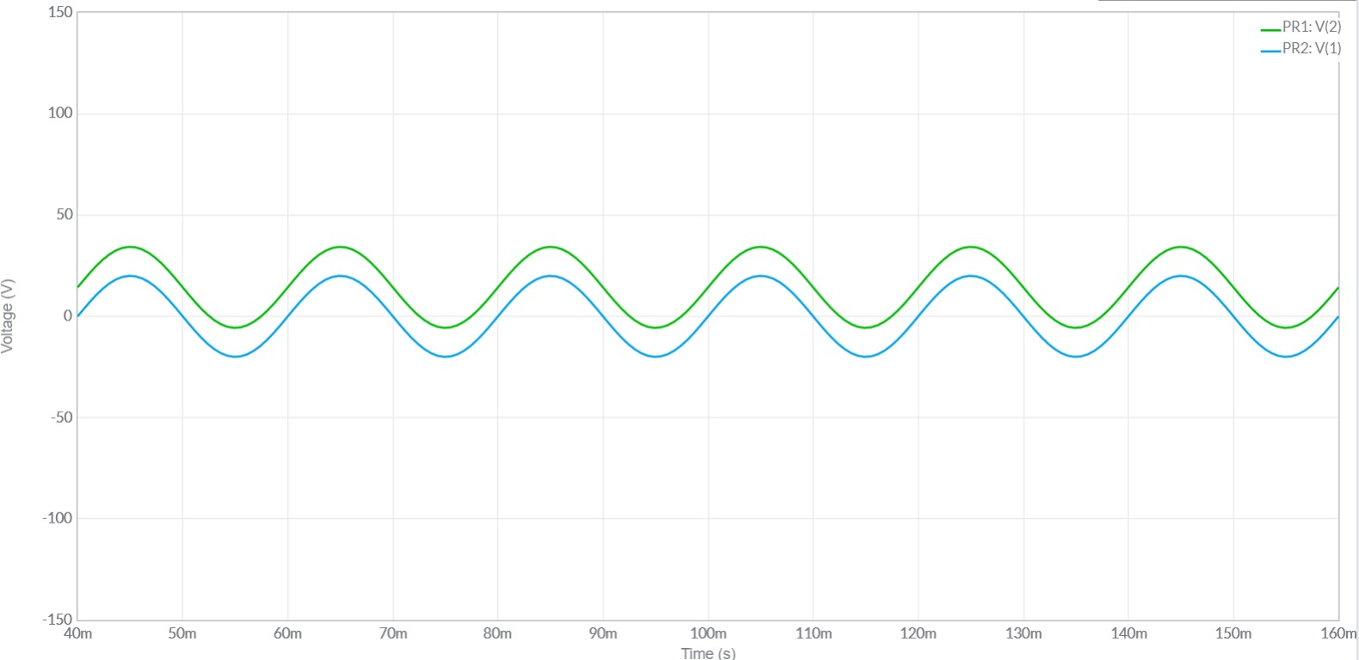

NEGATIVE CLAMPER (UNBIASED):

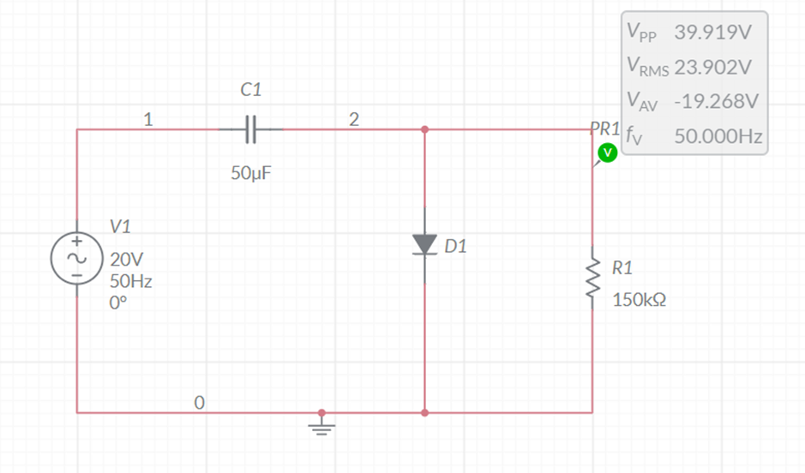

GRAPHS:

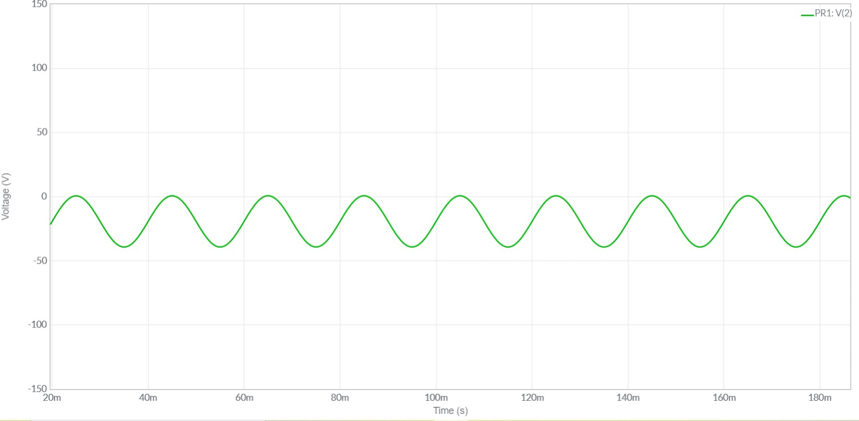

NEGATIVE CLAMPER WITH POSITIVE Vr:

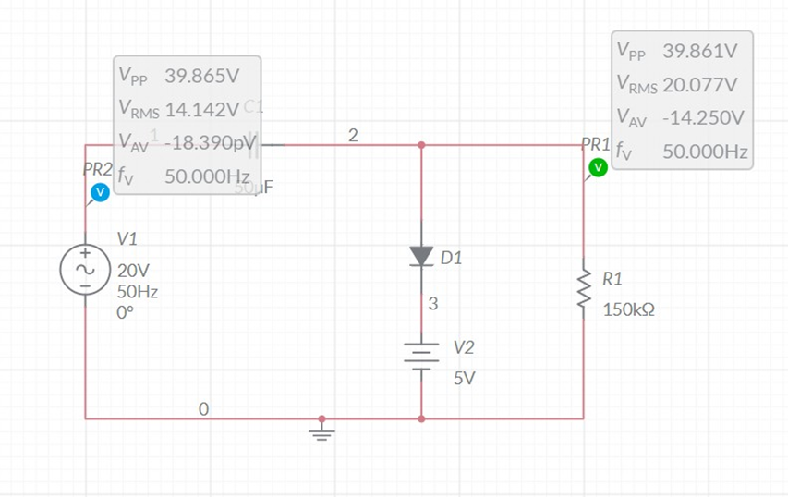

GRAPHS:

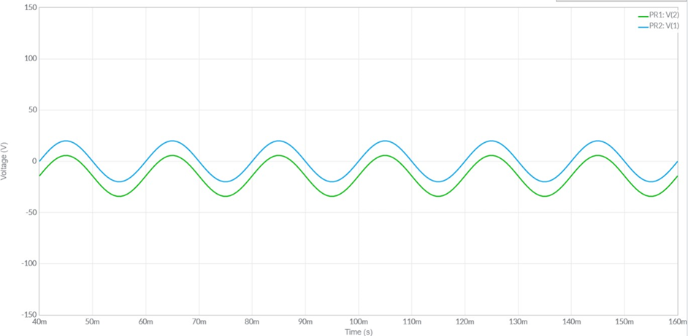

NEGATIVE CLAMPING WITH NEGATIVE Vr:

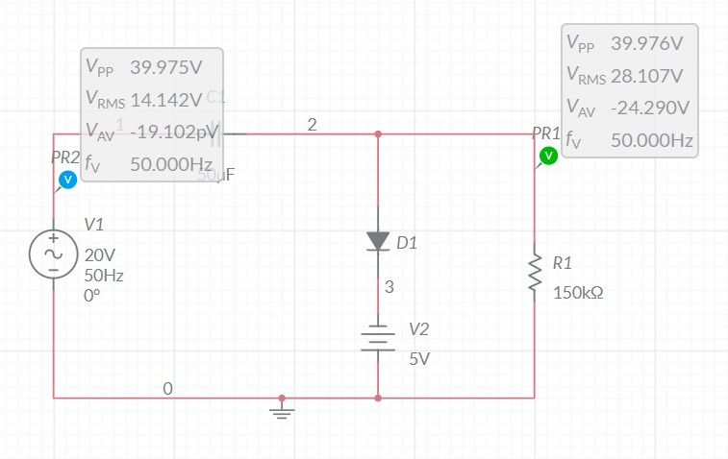

GRAPHS:

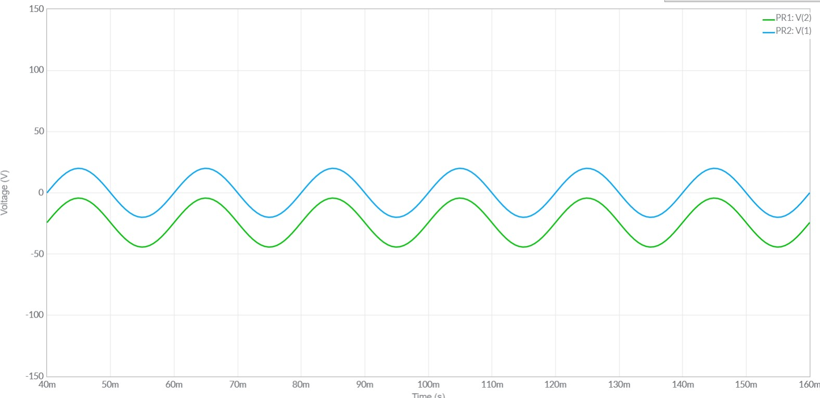

NAME: G R NITIN

ROLL NO: CB.EN.U4CYS21017